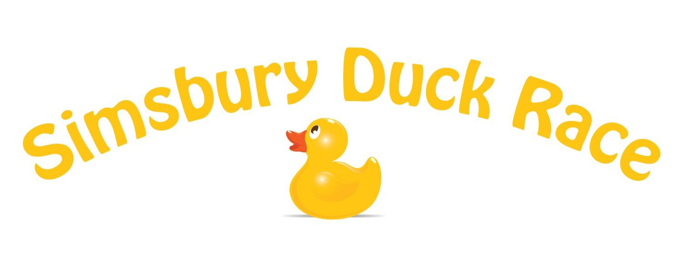
SPONSORSHIP FORM
- GRAND QUACKER PRESENTING SPONSOR ($1,000)
Includes your business name on event t-shirts, your own banner showcased at the entrance to the event, and your business featured as the Presenting Sponsor on our website, press releases, and promotions for the event. Business Duck and 20 racer duck tickets included.
- QUACKTACULAR SPONSOR ($750)
Includes your own banner at the event, special recognition during the contest, and promotion on our website, social media, etc. Business Duck and 10 racer duck tickets included.
- SWAN SPONSOR ($500)
Includes personalized signage and promotion on our website, social media, etc. Business Duck and 10 racer duck tickets included.
- MALLARD SPONSOR ($250)
Includes your name on the sponsor banner and promotion on our website, social media, etc. Business Duck and 5 racer duck tickets included.
- FOOD VENDOR ($150)
For vendors interested in selling food/beverages at the event. Includes a dedicated vending location at the event, your name on the sponsor banner, and promotion on website and social media. Business Duck included.
- BUSINESS DUCK ($100)
Includes your name on the sponsor banner and print and online media.
Business Ducks compete in the Best Decorated Duck Contest, followed by the Business Duck Race down the Farmington River. While we encourage businesses to attend and participate in the fun, you do not have to be present to win either contest. Winners receive a quack-tastic trophy to display at their business. Event is Friday, May 22nd from 4:00-7:00 PM.

COMPANY: WEBSITE:
CONTACT NAME: EMAIL:
ADDRESS:
PHONE:
PAYMENT TYPE:
- Credit Card. Go to www.simsburyduckrace.com, click on Purchase and choose your sponsorship level.
- Check. Payable to Tootin’ Hills PTO and mail to Simsbury Duck Race, 25 Nimrod Rd., West Simsbury, CT 06092. Donations are tax deductible. Tootin’ Hills PTO Tax ID # is 45-3798704.
- BUSINESS DUCK RACE: After the Best Decorated Duck Contest, our duck would like to participate in the Business Duck Race down the river. We understand the duck may lose some of its accessories during the race.
- After the Best Decorated Duck Contest, our duck will watch the Business Duck Race from the sidelines. We’re looking forward to displaying our duck in our place of business after the event and don’t want to risk losing its accessories.
- VOLUNTEER OPPORTUNITIES: YES! Employees at our company are interested in volunteering on race day.
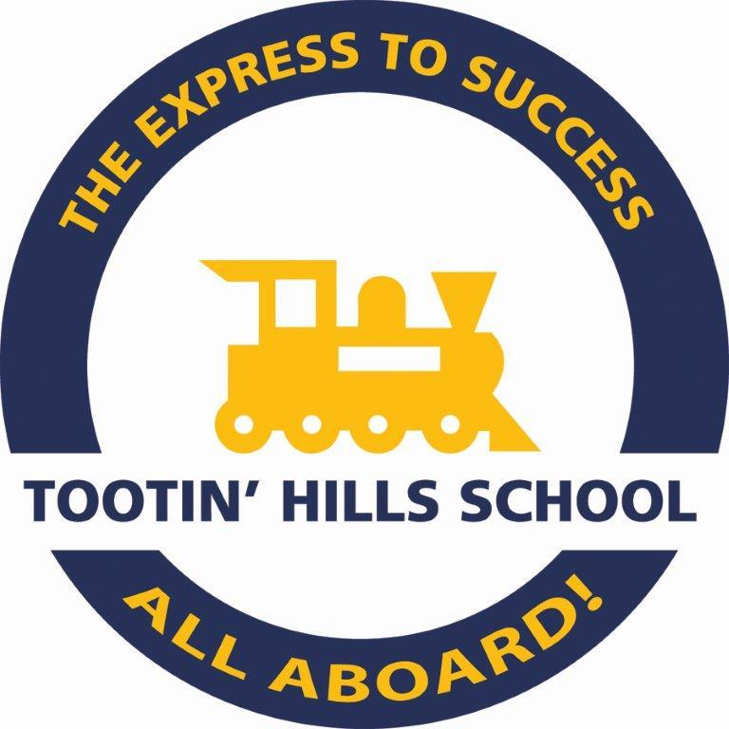
To be included on print materials, sponsorship forms and payment are due by May 1, 2026. Your duck will be hand-delivered to your business. For more information, visit www.simsburyduckrace.com or email tootinducks@gmail.com.

